Vibration sensor

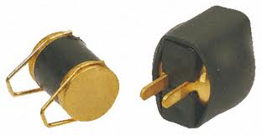

The LDT0-028K:

Does a flexible component comprise a 28 μm thick piezoelectric PVDF polymer film with screen-printed Ag-ink electrodes, laminated to a 0.125 mm polyester substrate, and fitted with two crimped contacts. As the piezo film is displaced from the mechanical neutral axis, bending creates very high strain within the piezopolymer and therefore high voltages are generated. When the assembly is deflected by direct contact, the device acts as a flexible "switch", and the generated output is sufficient to trigger MOSFET or CMOS stages directly. If the assembly is supported by its contacts and left to vibrate "in free space" (with the inertia of the clamped/free beam creating bending stress), the device will behave as an accelerometer or vibration sensor. Adding mass, or altering the free length of the element by clamping, can change the resonant frequency and sensitivity of the sensor to suit specific applications. Multi-axis response can be achieved by positioning the mass off center. The LDTM-028K is a vibration sensor where the sensing element comprises a cantilever beam loaded by an additional mass to offer high sensitivity at low frequencies.
FEATURES:

- Solder Tab Connection
- Both No Mass & With Mass Version
- Withstands High Impact
- Operating Temperature: 0ºC to 85ºC
- Storage Temperature: -40ºC to 85 ºC
- Higher Temperature Version up to 125 ºC available on a Custom Basis

APPLICATIONS:

- Vibration Sensing in Washing Machine
- Low Power Wakeup Switch
- Low Cost Vibration Sensing
- Car Alarms
- Body Movement
- Security Systems

